Procedure: | Complaint
Approved by: | Leadership Group
Date Approved: | May 2021
Frequency of review: | Every 3 years
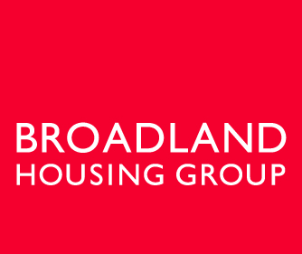

______________________________________________________________________________

- PURPOSE

The Complaints Procedure aims to support the Complaints Policy and provides further guidance and process information to assist staff with handling complaints.

Broadland Housing Association (BHA) aims for a quick resolution of all issues reported to us from our tenants and offer a transparent route for our complaint handling process whilst welcoming opportunities to learn from feedback to inform service delivery. The Complaints procedure has been drafted to meet current legislation, regulatory expectations and good practice, including the Housing Ombudsman Code published in July 2020.

The procedure is supplemented by guidance for staff and process flow-charts. The procedure will be publicised to customers in a range of sources.

Training will be provided to all staff, supported by training videos available within Broadland Business Systems (BBS)

- KEY STAFF RESPONSIBILITIES

Board
The Board is responsible for ensuring the continued development of certain policies. When a complaint reaches Stage 2, BHA Board members will sit on the complaint panel.

Senior management
The Management Team are responsible for ensuring that policies and procedures are followed by all concerned and promoting an anti-discriminatory environment for all to work. Senior Managers will deal with all Stage 1 complaints.

Staff
Employees are responsible for ensuring they are fully aware and adhere to the terms set out in the policy.

- OVERVIEW

Making a complaint
We aim to provide good quality homes and service, but sometimes things go wrong, and mistakes are made – we are all human!

We welcome complaints as a way to put things right, to learn and to improve. Complaints and expressions of dissatisfaction can be reported in any way convenient to the person complaining. This includes:
    - Tenants Online
    - Website enquiry
    - Telephone call
    - Face to face
    - Social media
    - Letter

We aim to resolve complaints quickly and to learn from them. For each stage of the complaints procedure, we have a focus on people first, then on recording and process.

In summary, the procedure is:

Swift Resolution – let’s get things sorted. We will listen and apologise where there are issues. We will respond quickly and focus on putting things right. We will record and monitor all swift resolutions so that we can spot any patterns, learn from our mistakes and improve. (Appendix A)

Stage 1: Formal complaint – let’s get another point of view. This marks the start of Broadland’s formal process. To make sure all complaints are treated fairly and investigated correctly, a Stage 1 complaint is always allocated to a member of the Senior Management Team. If a complainant is not satisfied with Broadland’s response to the swift resolution, or if they feel they want to make a formal complaint from the beginning, this is the stage that will be used. If a customer remains dissatisfied after stage 1, their complaint will be escalated to stage 2. (Appendix B)

Stage 2: Complaint Panel – what if you’re not satisfied? If a complainant is not satisfied with Broadland’s formal response at Stage 1, they can ask for their complaint to be escalated to Stage 2. At Stage 2, a panel made up of the Chief Executive plus two BHA Board meets to consider the complaint. The complainant will be given the opportunity to provide their input and can join the meeting if they would like. They are permitted to bring a friend or family member with them to the panel meeting. The panel will give Broadland’s final response and the reasons for their decision within five working days of the hearing. (Appendix C).

This is the final stage of Broadland’s complaints procedure.

If a complainant reaches the end of this procedure, the complainant can take their complaint to the Housing Ombudsman who will investigate. These rights of further appeal will be included in correspondence following a panel hearing.

- REVIEW

This procedure will be subject to ongoing review in the light of experience, changes in legislation and Group policy and meeting the needs of our stakeholders.

Appendix A

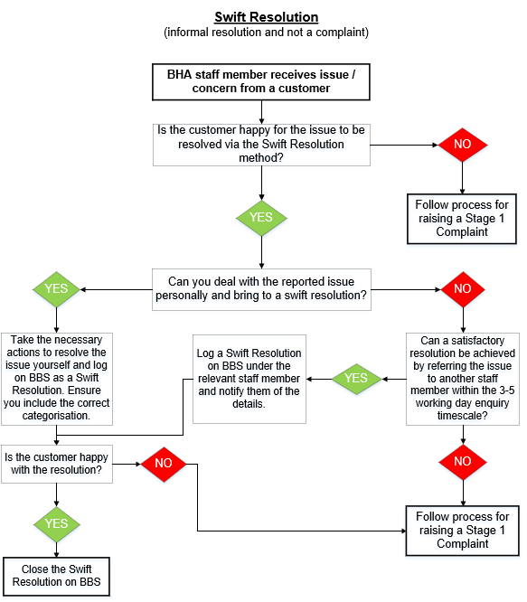

Appendix B

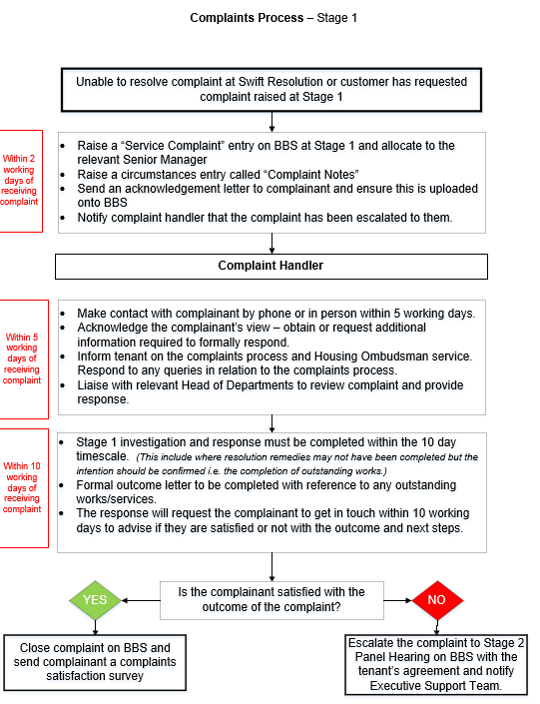

Appendix C

